CHAPTER 1 BASIC CONCEPTS

1.1 Overview : System Life Cycle

a solid foundation in data abstraction and encapsulation, algorithm specification, and performance analysis and measurement

provide the necessary methodology to design and implement large-scale S/W

regard programs as systems that contain many complex interacting parts

a development process : system life cycle requirements, analysis, design, coding, verification

Requirements

begin with a set of specifications that define the purpose of the project

must develop rigorous input and output descriptions

Analysis

break the problem down into manageable pieces

two approaches to analysis: bottom-up and top-down

1) the bottom-up approach

emphasis on the coding fine points

result in many loosely connected, error-ridden segments

2) the top-down approach

divide the program into manageable segments

refined to take into account low-level details

preferred approach for developing complex software systems

Design

perspectives of the data objects that the program needs and the operations performed on them

lead to the creation of abstract data types

require the specification of algorithms and a algorithm design strategies

specify the information required for each data object

ignore coding details

deferring implementation issues

create a system that could be written in several programming languages

have time to pick the most efficient implementation

Refinement and Coding

choose representations for data objects and write algorithms for each operation

a data object's representation determines the efficiency of the algorithm

should write the algorithms that are independent of the data object

if good design, then can absorb changes easily

Verification

develop correctness proofs for the program

test the program with a variety of input data

remove errors

1.2 Object-Oriented Design

using the philosophy of divide-and-conquer

break up a complex software design project into # of simpler subobjects

tackle simpler subobjects individually

1.2.1 Algorithmic Decomposition Versus O-O encapsulation

algorithmic or functional decomposition

view software as a process

decompose the software into modules(steps of the process)

modules : implemented by procedures or functions

O-O decomposition

view software as a set of well-defined objects that model entities in the application domain

objects interact with each other to form a software system

address functional decomposition after defining objects

advantage of O-O decomposition

reuse of software

flexible software systems that can evolve as system requirements change

1.2.2 Concepts of O-O Programming

Def. of object

an entity that performs computations and has a local state

viewed as a combination of data and procedural elemnets

Def. of O-O Programming

objects are the fundamental building blocks

encapsulation

each object is an instance of type

classification

inheritance relationships

is-a (generalization, specialization)

Def. of O-O language

support objects

require objects to belong to a class

support inheritance

object-based language : do not support inheritance

1.2.3 Evolution of C++

four generations of higher order programming languages

1) 1st generation: FORTRAN

ability to evaluate mathematical expressions

2) 2nd generation: Pascal and C

on effectively expressing algorithms

3) 3rd generation: Modula and Ada

introduce the concept of abstract data types

object-based language

4) 4th generation: O-O language (C++, Objective C, Smalltalk)

the use of inheritance

design of C++ : Bjarne Stroustrup of AT&T Bell Laboratories in the early 1980s

influenced by Simula67 and Algol68

the reason that C is widely-used in industry

efficient: # of low-level features, which utilize hardware

flexible: used to solve problems in most application areas

available for most computers

C++: improve on C

implement data abstraction or inheritance

other improvements

1.3 Data Abstraction and Encapsulation

Def. of data encapsulation or information hiding

the concealing of the implementation details of a data object

Def. of data abstraction

the separation between the specification of a data object and its implementation

abstraction, encapsulation, information hiding result in better quality programs and more efficient programming techniques

the fundamental data types of C++

char, int, float, double

modifiers: short, long, signed, unsigned

support types derived from the fundamental data types

include pointer and reference types

three mechanisms for grouping data in C++

the array

structs

classes

Def. of data type

a collection of objects and a set of operations that act on those objects

Def. of abstract data type

separate the specification of the objects and the specification of the operations from the representation of the objects and the implementation of the operations

emphasize the distinction between specification and implementation

Example 1.1 [Abstract Data Type NaturalNumber]

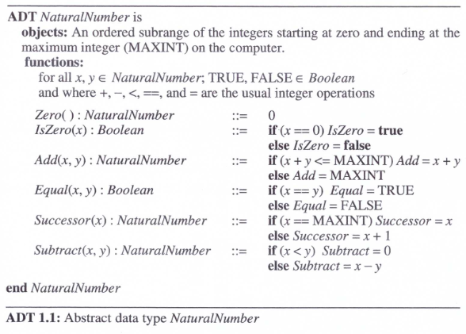

Two main sections in the definition: the objects and the functions

define the objects in terms of the integers

makes no explicit reference to their representation

makes use of functions that are defined on the set of integers, namely plus, minus, equal, less than ..

develop well-designed programs by using data abstraction and encapsulation

Simplification of a software development

use the concept of data abstraction

facilitate the decomposition of the complex task into # of simpler subtasks

a top-down review of the problem

three data types A, B, C will be used

some additional code(called glue) to facilitate interactions among the three data types

provide the specifications of each data type

scenario 1: a team of 4 programmers

assign a programmer to each of the three data types

implement his data type according to the specifications

no needs to know how the other programmers implement their portion of code

scenario 2: a single programmer

implement each data type one by one according to the specifications

help reduce # of things the programmer has to keep in mind at any time

Testing and Debugging

can test and debug each data type separately

simplify testing and debugging
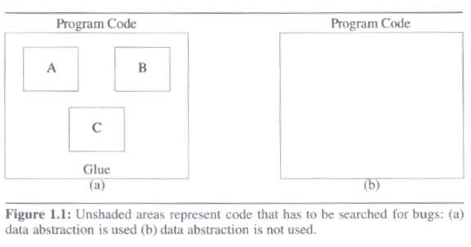

Reusability

make it easier to extract the code for a data structure and its operations from a software system and use it in another software system

data abstraction and encapsulation: lead to implement data structures as distinct entities of a S/W system

Modifications to the representation of a data type

by information hiding, the implementation of a data type is invisible to the other program

a change in the internal implementation of a data type without affecting the rest of the program

1.4 Basics of C++

"a better C" : the expression is used to describe the C++ language

C and C++ having common features

C++ has # of features not associated with data abstraction and inheritance

1.4.2 Scope in C++

File scope

declarations that are not contained in function scope or class scope

Function scope

use labels anywhere within the function definition in which they are declared

only labels have function scope

only used as the targets of go to statements

Local scope

a name declared in a block : belong to a local scope consisting of that block

Class scope

declarations associated with a class definition

each class represents a distinct class scope

class의 instance variables

a variable is visible to a program only from within its scope

only access a variable defined in a block from within the block

can access a variable defined at file scope(a global variable) anywhere in the program

use the scope operator ::

a local variable reuses a global variable name in a block

want to access the global variable

use the scope operator to access the global variable

use extern

to declare the variable in another file

use static

to declare the same global variables in two files

means different entities

1.4.3 C++ statements and operators

new and delete

<<, >> operators

operator overloading

allowed to have different functions depending on the types of the operands

dynamic binding?

polymorphism과의 차이는?

1.4.4 data declarations in C++

referenced types : a feature of C++ that is not a feature of C

a mechanism to provide an alternate name for an object

int i = 5;
int &j = i;

j is a reference type

1.4.6 I/O in C++

cout / cin

<< operator

Program 1.1: Output in C++

Program 1.2; Input in C++

Program 1.3; File I/O in C++

1.4.7 Functions in C++

two kinds of functions in C++: regular functions and member functions

member functions : functions that are associated with specific C++ classes

function 구성:

a function name, a list of arguments or signature (input), a return type, the body

Program 1.4: An example of a function

1.4.8 parameter passing in C++

passed by value

the default parameter-passing mechanism

actual arguments are not inadvertently modified

passed by reference

need to explicitly declare an argument to be a reference type

execute faster if the object being passed requires more memory than its address

because the overhead of copying the actual argument into the function's local store

pass constant references such as const T& a

const T&는 타입

one technique for retaining the advantages of both parameter-passing method

any attempt to modify a const argument in the function body : a compile-time error

one exception to the default parameter passing mechanism

array types are passed by reference

the array is not copied into the function's local store

with an array argument a (e.g., f(a))

a pointer to the first element of a (i.e., &a[0])

usually denote arrays by pointers to the appropriate (e.g., f(int *a))

explicitly passing the size of the array as a separate parameter of the function

1.4.9 Function name overloading in C++

function overloading

more than one function with the same name as long as they have different signatures

int max(int, int);
int max(int, int, int);
int max(int *, int);
int max(float, int);
int max(int, float);

1.4.10 Inline functions

replace any calls to sum by the body of sum

eliminate the overhead of performing a function call and copying arguments

inline int sum(int a, int b)
{
return a + b;
}

1.4.11 Dynamic memory allocation in C++

int *ip = new int;
//new: create an object of the desired type
// return a pointer to the data type
. . .
delete ip;

int *jp = new int[10];
. . .
delete [ ] jp;

subscript operator ([ ]) : to inform the compiler that the object being created or deleted is an array
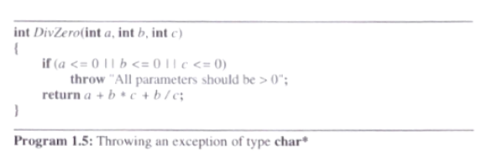
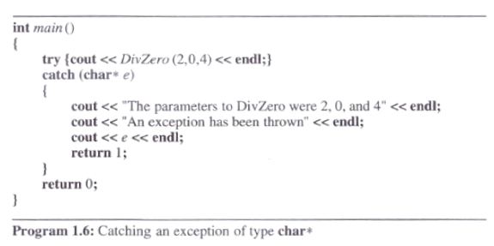

1.5 Algorithm Specification

1.5.1 Introduction

Def. of algorithm

a finite set of instructions that accomplishes a particular task

satisfy the following criteria

input

zero or more quantities are supplied

output

produce at least one quantity

definiteness

clear and unambiguous instruction

finiteness

the algorithm terminates after a finite number of steps

effectiveness

must be feasible

every instruction must be basic enough to be carried out, by a person using only pencil and paper

differences between an algorithm and a program, in computational theory

a program does not have to satisfy finiteness criteria

an example : operating system

Example 1.2 [selection sort]

devise a program that sorts a collection of N integers

a simple solution

"From those integers that are currently unsorted, find the smallest and place it next in the sorted list"

is not an algorithm -> not tell where and how the integers are initially stored or where we should place the result

not-effective and/or not-definite ?

예: place it next: unclear instruction

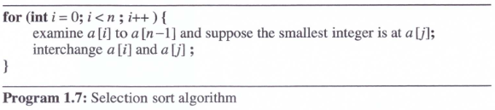

turn Program 1.7 into a real C++ program

called refinement

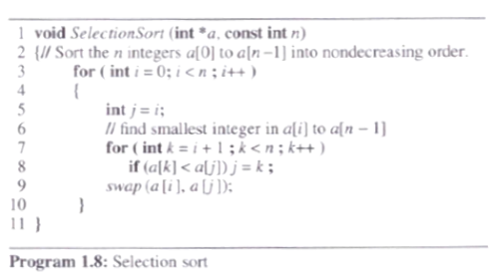

Example 1.3 [Binary search]

n>=1 distinct integers that are already sorted in a[0], . . ., a[n-1] determine if the integer x is present and if so to return j (x = a[J]); otherwise return -1

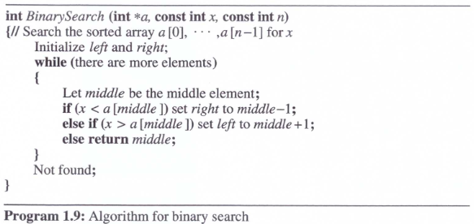

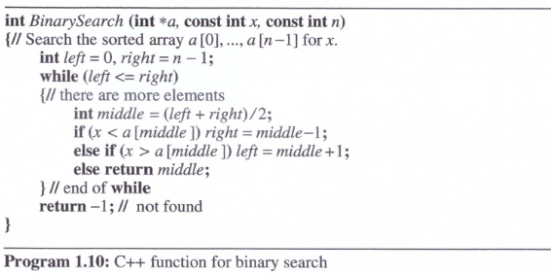

1.5.2 Recursive algorithms

a recursive function requires a terminating condition

any program written using assignment, if-else statement, while statement can also be written using assignment, if-else, and recursion

when is recursion an appropriate mechanism for algorithm exposition?

when the problem itself is recursively defined

example: factorial computation N! = N * (N-1)!

Example 1.4[Recursive binary search]

pass left and right as parameters in the recursive version
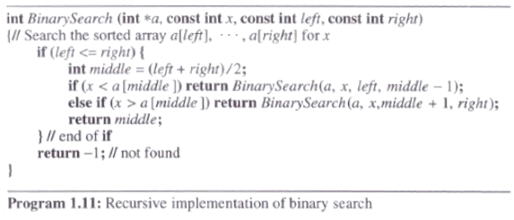

invoke the recursive function : BinarySearch(a, x, 0, n-1)

Example 1.5[Permutation generator]

print all possible permutations of set

n! different permutations for given n elements

look at the four elements (a, b, c, d)
a followed by all permutations of (b, c, d)
b followed by all permutations of (a, c, d)
c followed by all permutations of (a, b, d)
d followed by all permutations of (a, b, c)

"followed by all permutations" : recursion

can solve the problem for a set with n elements if we have an algorithm that works on n-1 elements

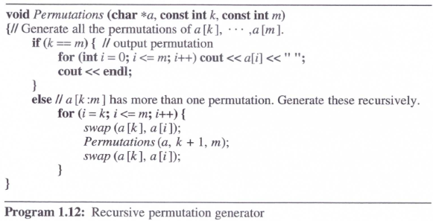
//I = 0 => permutation a,xxx
//I = 1 => permutation b,xxx
//I = 2 => permutation c,xxx
//I = 3 => permutation d,xxx

Call perm(a, 0, n);

1.7 Performance Analysis and Measurement

performance criteria for judging programs

Definition:

time complexity: the amount of computer time a program needs to run to completion

a priori estimates of performance evaluation: performance analysis

a posteriori estimates of performance evaluation: performance measurement

1.7.1 Performance Analysis

1.7.1.2 Time Complexity

the time, T(P) = the sum of the compile time and the run time

the compile time : independent of the instance characteristics

count only the number of program steps

define a program step as a segment of a program (independent of the instance characteristics)

return a+b+b*c+ (a+b-c)/(a+b)+4.0; -> regarded as a step

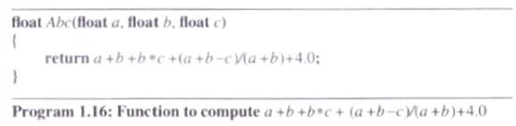

1st method to determine the number of steps needed by a program

introduce a new variable, count, into the program
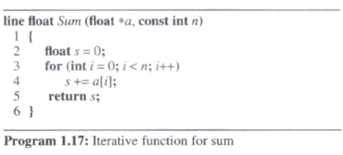

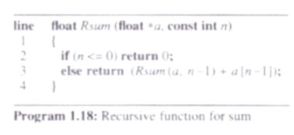

Example 1.11

introduce a new variable count into program 1.17

trsum(n) = the increase in the value of count when program 1.17 terminates

trsum(0) = 2

trsum(n) = 2 + trsum(n-1)

referred to as recurrence relations

float rsum(float *a, const int n)
{
count++; // +1
if (n<= 0) {
count++;
return 0;
}
else {
count++; // +1
return (rsum(a, n-1) + a[n-1]); // trsum(n-1)
}
}

Program 1.19: Program 1.18 with count statements added

trsum(0) = 2

trsum(n) = 2 + trsum(n-1) = 2*2+ trsum(n-2)

= 2n + trsum(0) = 2n+2

expect the run time to grow linearly in n

the time complexity is linear

2nd method to determine the step count of a program

determine the number of steps per execution of the statement and the total number of times(frequency) each statement is executed

an important difference between the step count of a statement and its steps per execution (s/e)

the step count: not reflect the complexity of the statement

x = sum(a, m)

1) a step count = 1

2) the total change in count

= 1 + the change resulting from the invocation of sum: (2m+3)

Table 1.2: Step table for Program 1.18

line 2(a) : the if condition of line 2

line 2(b): the statement in the if clause

line 3: 1+trsum(n-1), under the s/e(steps per execution)
- 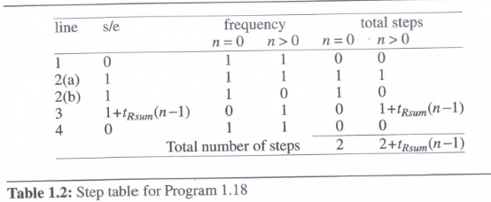

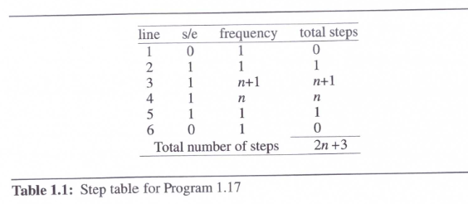

have to analyze the time complexity of the program fibonacci

should be able to solve the similar problems (recursions)

Program 1.21: Fibonacci numbers

1.7.1.3 Asymptotic notation

a difficult task to determine the exact step count

two programs with a complexity of c₁n2 + c₂n and c₃n respectively

if c1 =1, c2 = 2, c3 = 100

then c1n2 + c2n <= c3n for m<= 98

c1n2 + c2n > c3n for n>98

the break-even point : the value of n 98

Def. of Big "oh"

f(n) = O(g(n)) iff f(n) <= cg(n) for all n, n>= n0, constant c

g(n) is an upper bound on the value of f(n) for all n

not say anything about how good this bound is

f(n) = O(n2), f(n)=O(n2.5), f(n) = O(n3)
.

Example 1.15

3n+2 = O(n) for all n>=2

10n**2+4n+2 = O(n**2) as

10n**2+4n+2 <= 11n**2

6*2n+n*n = O(2n) as

6*2n+n*n <= 7*2n for n>=4

3n+3 = O(n2) as 3n+3 <= 3n**2 for n>=2

10n**2 + 4n+2 = O(n4)

O(1): constant

O(n): linear

O(n2): quadratic, O(nlogn) is better than O(n2):

O(2n): exponential

f(n) = O(g(n))

g(n) should be small (to be informative)

Theorem 1.2:

if f(n) = amnm+ ... + a1n + a0, then f(n) = O(nm)

Def. of Omega

f(n) = (g(n)) iff f(n) >= g(n)

Example 1.16

3n+2 = (n) as 3n + 2 >= 3n for n>=1

10n**2 +4n+2 =(n**2)

3n+2 = (1)

6*2n+n2 = (n)

g(n) is only a lower bound on f(n)

g(n) should be as large a function of n as possible

Theorem 1.3:

if f(n) = amnm+ ... + a1n + a0,

then f(n) = (nm)

Def. of Theta

f(n) =(g(n)) iff c1g(n) <= f(n) <= c2g(n)

g(n) is both an upper and lower bound on f(n)

Example 1.17

3n+2 = (n)

10n**2+4n+2 = (n**2)

3n+2 != (1)

3n+2 != (n**2)

Theorem 1.4:

if f(n) = amnm+ ... + a1n + a0, then f(n) = (nm)

determine the asymptotic complexity of each statement and then add up these complexities

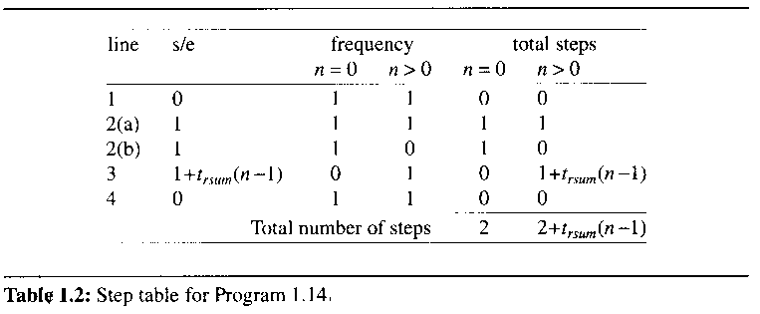

line 3: 2 + trsum(n-1)

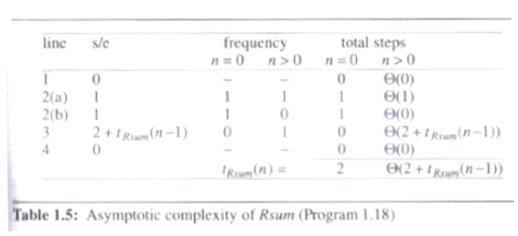

1.7.1.4 Practical Complexities

complexity (n) is faster than complexity (n2) for sufficiently large n

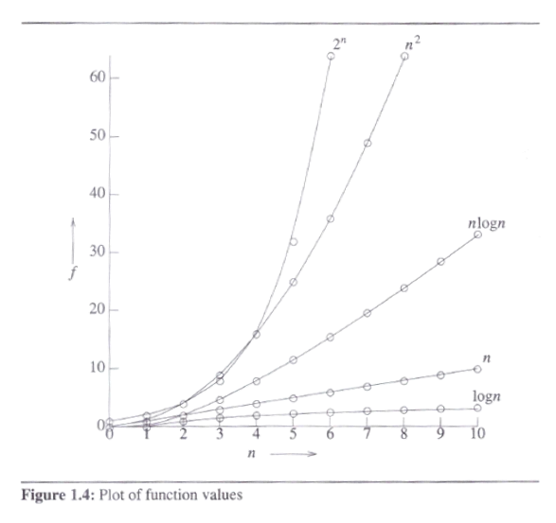

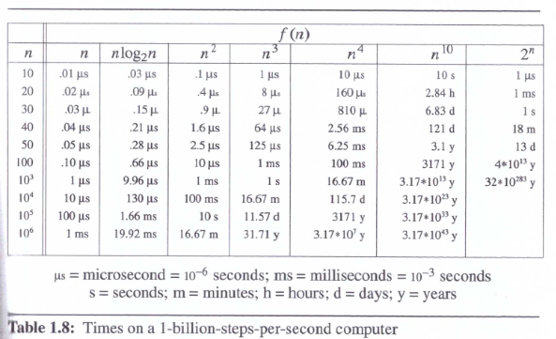

the time needed by a 1-billion-steps-per-second computer to execute a program of complexity f(n) instructions

currently only the fastest computers can execute about 1 billion instructions per second

1.7.2 Performance Measurement

need a clocking function: time(hsec) that returns in the variable hsec the current time in hundredths of a second

wish to measure the worst-case performance of the sequential search function(program 1.23)

asymptotic analysis : (n)
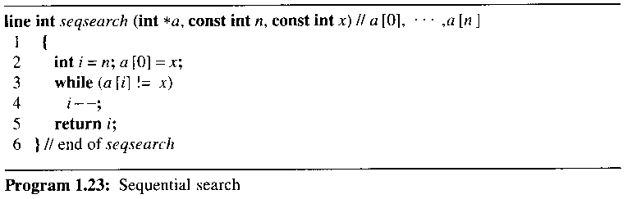

decide on the values of n for which the times are to be obtained

need the times for more than two values of n

may not follow the asymptotic curve for smaller values of n

may not lie exactly on the predicted curve because low-order terms are discarded

determine, for each of the above values of n, the data that exhibits the worst-case behavior

exhibit worst-case behavior when x is chosen such that it is not one of the a[i]'s or set a[i] = i and x = 0
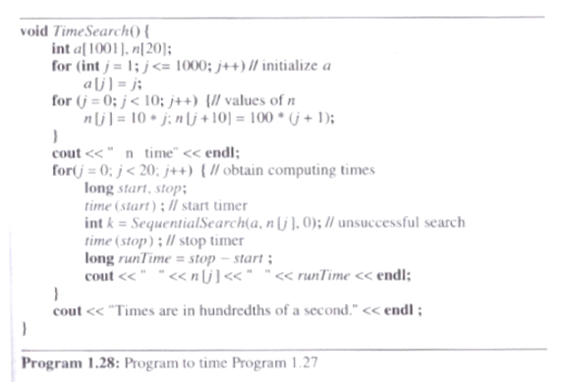

inadequate precision of clock

necessary to repeat to time a short event several times and divide the total time for the event by the number of repetitions
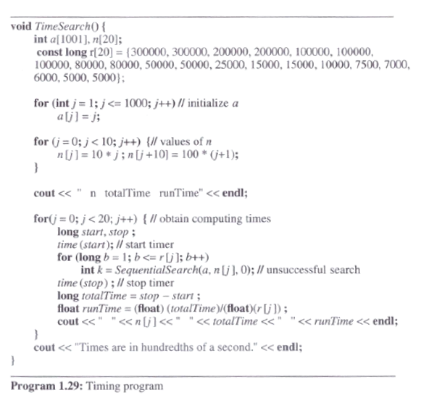

r[j]: # of times the search is to be repeated when # of elements in the array is n[j]

